Summer Retreat, August 4-6, 2017

Messiah College, Grantham, PA

3 pm Friday – 1 pm Sunday

**Discipleship for the**

**Glory of God**



Meaning

Mandate

Model

Method

**Retreat Speaker - David Moyer**

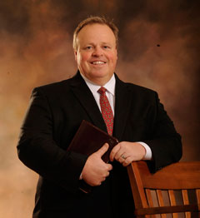

*Dave Moyer is the Executive Director of The Maryland Bible Society and a Field Partner with CBMC, an international ministry committed to workplace evangelism and discipleship. Dave serves as an Elder and Associate Pastor of Discipleship at Long Green Baptist Church. Dave and his wife, Cindi, are the proud parents of six children.*

🙞🙜🙞🙜🙞🙜

**Come to …**

*Be instructed in God’s Word*

*Be encouraged through fellowship*

*Be renewed by putting aside the cares of the world for a weekend*

Besides the teaching, the schedule includes worship, sharing, plenty to eat, free time to enjoy the campus, recreation or nearby attractions. We are pleased that Chinese Children’s Ministry will conduct sessions for the elementary-age children again.

🙞🙜🙞🙜🙞🙜

.

Reservation deadline is July 23, 2017. $10 discount for those registering by July 9

(form and payment). Contact the church with questions or for a brochure.

Click here for online registration form.