Summer Retreat, August 3-5, 2018
Messiah College, Grantham, PA
3 pm Friday – 1 pm Sunday

Joy Unspeakable!
A focus upon the deep well of Joy
available to God's people
regardless of their circumstances.
A study in Philippians.

Retreat Speaker – Dan Ho
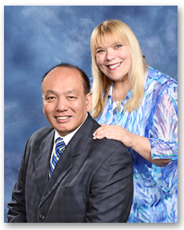
"Pastor Dan and Barb Ho have previously spoken at CCC's 2011 and 2012 summer retreats. Pastor Dan is currently the senior pastor of Chinese Baptist Church of Houston, the first Asian church in the city of Houston. In almost four decades of ministry, Pastor Dan and Barb have been blessed to see many people give their hearts to the Lord. This is their passion: to reach the lost for Jesus Christ. The Great Commission given by the Lord in Matthew 28:18-20 and Acts 1:8 contain the whole purpose of their calling. This is what they want to do until the Lord returns or takes them home."

Come to …
Be instructed in God’s Word
Be encouraged through fellowship
Be renewed by putting aside the cares of the world for a weekend
Besides the teaching, the schedule includes worship, sharing, plenty to eat, free time to enjoy the campus, recreation or nearby attractions. We are pleased that Chinese Children’s Ministry will conduct sessions for the elementary-age children again and Barb Ho will conduct a special workshop on Saturday afternoon.

.
Reservation deadline is July 23, 2018. $10 discount for those registering by July 9
(registration form and payment). Click here for registration form or
contact info@cccdc.com or aaron.woo@cccdc.com with questions.

