* Contact the Church office at (202) 637-9852 or Aaron Woo (aaron.woo@cccdc.com) or Linda Wong ([linda@cccdc.com](mailto:linda@cccdc.com)) at church if you have questions.
* Deadline for registration: 07/22/19
* Scholarships available
* Keys and meal cards will be issued to all participants.
* Room assignments will be made in Hess Dorm or Fry Apartments.

**Facilities:**

* Quiet, picturesque campus
* Modern, air-conditioned dorms with kitchenette, lounge areas, and large bathrooms; apartments available for families
* All linens (bedding and towels) provided
* Food Court Service – all you can eat, hot and cold choices
* Recreation – indoor pool, outdoor and indoor basketball and volleyball courts, tennis courts, walking trails, playing fields, fitness trail
* Babysitting arranged for toddlers to 4 years
* Children’s program (Chinese Children’s Ministry for elementary-age students)

**Directions to Messiah College:**

[From I-270 at Falls Road it is a 1 hour, 40 minute ride]

1. Go north on I-270 for about 30 miles from the Capital Beltway.

2. In Frederick, proceed onto Rt. 15 north towards Gettysburg. At the Rt. 15 and Rt. 70 fork, take the left fork.

3. Continue on Rt. 15 into PA to Dillsburg - About 45 miles from the state line.

4. Approximately 4.0 miles beyond the PA 74 North intersection near Dillsburg take the Lisburn Road exit. At the bottom of the ramp, turn right on Lisburn Road and continue to the stop sign.

5. At the traffic circle, take the 1st exit onto Grantham Road.

6. Continue .2 miles.

7. You will be at the main entrance in front of the welcome sign. Turn right at the stop sign on College Avenue.

Registration will be in Eisenhower Campus Center – Guest Relations Desk from 3-5 pm. Dinner is from 5:00 - 6:00 pm in Eisenhower. Alternate dinner arrangements will be made for late arrivals. Most meetings are scheduled to be in Parmer Auditorium in Boyer Hall.

**THINGS TO BRING:**

Bible and personal devotion materials, Clothing for two full days including sweater/jacket, Personal toiletries, Swimsuit and towel for wading in the creek, Comfortable shoes, Athletic gear (volleyball and net provided)

**No** boom boxes or items which will distract or interfere with anyone’s retreat experience will be allowed.

Details:

**Chinese Community Church**

Summer Retreat 2019

***Providence: Tracing God’s Hand in the Book of Ruth***

500 I Street, NW

Washington, DC 20001

Phone: 202-637-9852

Web site: www.cccdc.com



|  |  |  |  |  |  |  |  |
| --- | --- | --- | --- | --- | --- | --- | --- |
| **Registration**  **Deadline – July 22, 2019** |  | | |  |  |  | |
| Name | | | | | | | |
| Address | | | | | | | |
|  | | | | | | | |
|  | | | | | | | |
| Phone | | | | | | | |
| E-mail  Fees: (Early Bird Rate - paid by June 30)  Adult - $150 (140)  Students - $110 (100) (teens)  Children - $ 90 (80) (ages 5-12)  Family maximum (living in same  household) - $500 (450)    List first name of each person attending:   |  |  |  |  |  |  | | --- | --- | --- | --- | --- | --- | | Name | Age <18 | Roommate | Fee |  |  | |  |  |  |  |  |  | |  |  |  |  |  |  | |  |  |  |  |  |  | |  |  |  |  |  |  |   Total _____  _______ | | | | | | | |
| Method of Payment | | | | | | | |
|  Cash ________  Check __________ | Ch  Ceck |   | MasterCard | | | |
| Checks payable to Chinese Community Church | __ | ❒ | American Express | | | |

Transportation Information:

 Need Ride  Can drive

Day & Time of arrival: _____________________

Departure Time: __________________________

Turn in form and fees to Linda Wong or Aaron Woo or email to [info@cccdc.com](mailto:info@cccdc.com)

**Retreat Speaker**

**Jason Tarn**

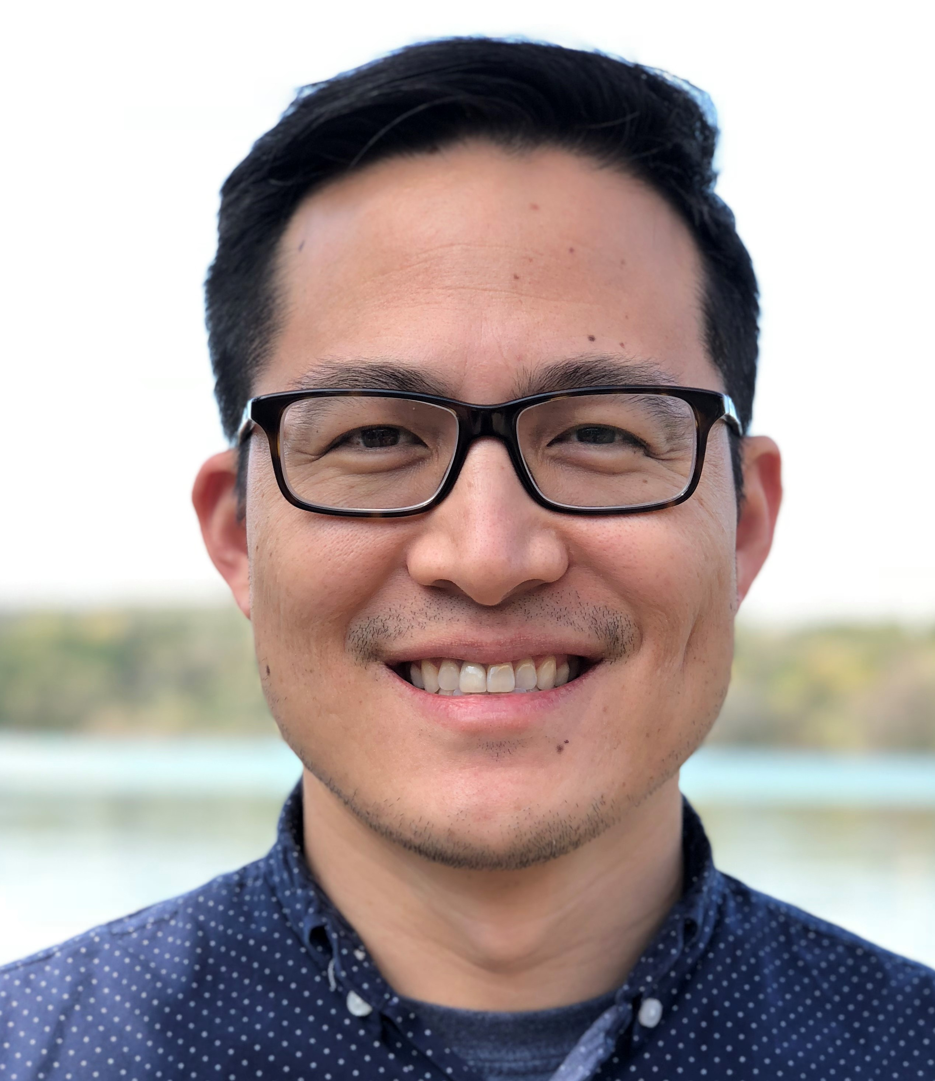

Jason Tarn is the English Pastor of Houston Chinese Church (HCC). He received his bachelor's from UT Austin and completed an M.Div. at Regent College. Currently, he is completing a Doctorate of Ministry in Expository Preaching at the Southern Baptist Theological Seminary. Jason grew up at HCC since the age of 12 and has served there on staff for over twelve years in total. His passion is to bring healthy reform to the immigrant church that is rooted in sound doctrine and a missional vision. He is married to Theresa and they have a daughter. You can follow him on Twitter @jasontarn.

# Messiah College

Grantham, PA

August 2-4, 2019

Friday, 3 pm until Sunday, 1 pm

**Program Overview**

*God’s Hand in our Suffering - Ruth 1*

Nothing just happens by chance. Nothing is attributable to mere fate. Everything is guided by God’s providential hand – even suffering.

*God’s Hand in our Blessing - Ruth 2*

People attribute blessings in life to sheer coincidence or the kindness of others, but the eyes of faith can see the Lord's favor as the real source.

*God’s Hand in our Romance - Ruth 3*

God’s hidden hand is present in all the risks we take in life, that includes falling in love. Confidence in this truth should inspire patience, purity, and piety as you pursue romantic love.

*God’s Hand in our Redemption - Ruth 4*

As the story of Ruth concludes, we come to realize a bigger story exists. As the camera zooms out, it becomes clear that, in God’s providence, our ordinary lives contribute to something bigger than ourselves.

🙜🙞

Be instructed in God’s Word

Be encouraged through fellowship

Be renewed by putting aside the cares of the world for a weekend