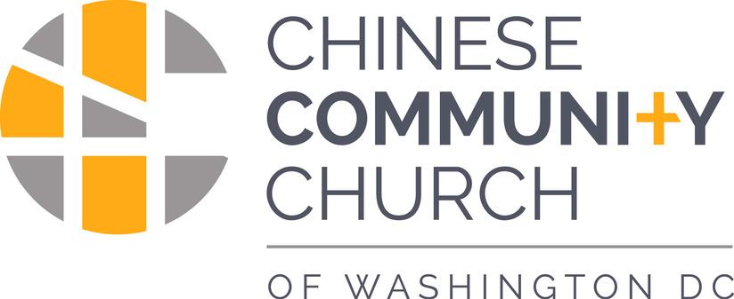
美京中華基督教會

EASTER SUNDAY復活節主日
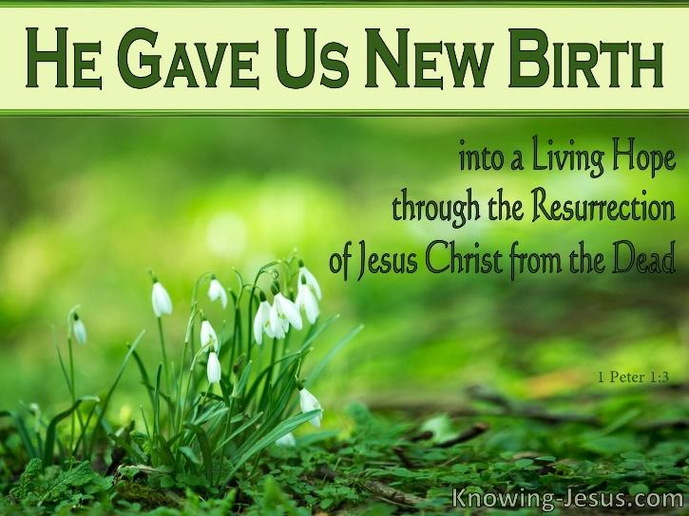
April 17, 2022, 10:45 am

WELCOME TO CCC! 美京中華基督教會歡迎您

We are glad you are here! As a Christian community desiring to exalt God, we serve together seeking to introduce Christ to the people, follow Him, and grow in love with God and others. In worshiping with us, we pray you might experience the good news of Jesus. If this is your first time, please complete a connect card and return the card to an usher. 我們很高興你能來！ 作為高擧神的一個基督團體，我們共同努力使大家認識基督、跟隨他，並在愛上帝和彼此相愛中成長。在敬拜中我們為您禱告，使您可以體驗耶穌基督的福音。請第一次來訪的朋友填寫來賓卡並將卡片交還給招待同工。

ORDER OF SERVICE 敬拜程序
UNITY CHURCH

Welcome 歡迎
Opening Prayer 禱告
Praise 讚美
Christ the Lord Is Risen Today 基督耶穌今復活
Because He Lives 因祂活著
Scripture Reading 讀經：1 Peter彼前 1:3-5
Sermon 證道：Security in Christ 主裏安穩
Closing Hymn 讚美詩: Blessed Assurance 有福的確據
Announcements 報告
Prayer and Benediction 禱告、祝福

Moderator主持人: Pastor Charles Koo辜漢然牧師
Prayer禱告: Pastor Joanna Xu徐麗娟傳道
Sermon証道: Pastor Joshua Cho曺富鉉牧師
Pianist鋼琴伴奏: Chris Cho曹志輝

✠✠✠✠✠✠✠✠
辜漢然主任牧師REV. CHARLES KOO (粵語Senior Pastor, C - Cantonese)
曺富鉉牧師REV. JOSHUA CHO (曺語E - English)
徐麗娟傳道PASTOR JOANNA XU (國語M - Mandarin)
500 I STREET NORTHWEST, WASHINGTON, DC 20001
(202) 637-9852 I CHURCH.OFFICE@CCCDC.COM I WWW.CCCDC.COM

CHILDREN – Lower Basement and ZOOM
SUNDAY SCHOOL, 9:30 am主日學
For K-5th Graders. Contact Everett Lum [sunday.school@cccdc.com] with questions. 兒童主日學：教堂地下室下層教室和ZOOM平臺實時網絡課堂
適合幼稚園至小學5年級的學生。任何問題請發送電子郵件向林一劼查詢：ejlum@outlook.com
MIDDLE & HIGH SCHOOL - Upper Basement 中學生主日學：教堂地下室上層教室
COLLEGE - Room 303 高中生/大學生主日學：303教室
ADULT [E] - Room 304 & Google Meet 英文成人主日學在304室和網絡
No class on April 17. New series That the World May Know, God Heard Their Cry began April 10. All are welcome.
ADULT [M] – Fellowship Hall and Zoom國語成人主日學在楨桂堂和網絡
BIBLE STUDY & FELLOWSHIP GROUPS 團契和小組聚會
LEAF (Ladies English Adult Fellowship) I Mondays I 7:30 PM I Zoom or In-person Contact Grace or Nichole Chen (nyc8@georgetown.edu).
CCCYP (YOUNG PROF. ) I Wednesdays I 7:30 PM I Fellowship Hall
Fellowship and Bible Study. Contact Pastor Josh (joshua.cho@cccdc.com)
CCCYG (YOUTH GROUP) I 2ND, 3RD, 4TH Fridays I 7:00 PM I ZOOM
Contact Pastor Josh or Everett Lum (sunday.school@cccdc.com) for zoom link
GENERATIONS I 2ND & 4TH Fridays I 8:00 PM I ZOOM
Bible study and fellowship for families and youth/college students. Contact Aaron (aaron.woo@cccdc.com) or Tom (joandtomkee@yahoo.com) for details.
VA BIBLE STUDY AND PRAYER I 1ST & 3RD Wednesdays I 8:00 PM I ZOOM
Contact Wai Chen (waichen48@gmail) for link and details.
SOUL SISTERS I Monthly outing usually on Saturdays
Contact Joanne Kee for details.
粵語提摩太查經班 (Timothy Bible Study)：每月第一個星期六上午10點。欲知鏈接方式，請聯絡辜牧師。
聖經100樂讀：每月第二個星期六上午10點。欲知鏈接方式，請联系辜牧師。
維州查經、禱告會（粵語和英語）：每個月的第一和第三個星期三的晚上8點聚會，欲知鏈接方式，請聯絡陳偉忠。
国语堂青年团契查经和门徒培训：星期日晚上11点。详情请联系 徐丽娟传道。
餐福查经班（国语）：星期二和星期三下午2点，详情请联系 徐丽娟传道。
国语餐福团契：星期日晚上10点30分。欲知链接方式，請联系辜牧師或张飞敏。
THIS WEEK, April 17-23, 2022 本周2022年4月17-23日

[contact info@cccdc.com or leader for meeting details]
Sunday星期日
9:30 am Sunday School (Children, Adult [M] 兒童、囯/英主日學
10:45 am Joint Sunday Worship, Sanctuary聯合崇拜、大禮堂
Monday 星期一
7:00 pm Ladies English Adult Fellowship
Tuesday 星期二
2:00 pm Restaurant Bible Study [M] 國語餐福查經班
6:00 pm ESL Classes 英文課
7:00 pm Prayer Meeting and Bible Study [M] 國語查經/禱告會
Wednesday 星期三
11:00 am Pastors’ Meeting 牧者會議
2:00 pm Restaurant Bible Study [M] 國語餐福查經班
7:30 pm CCC Young Adult Fellowship [E] 英文青年團契
7:45 pm Prayer Meeting [C] 粵語禱告會
8:00 pm VA Bible Study and Prayer [C & E]維州查經、禱告會
10:00 pm Retiree Bible Study [M]退休人員查經團契
Friday星期五
6:00 pm Citizenship Class殖民班
7:00 pm Teen Youth Group青少年團契
8:00 pm Generations Bible Study英文查經班
Saturday
9:00 am Chinese Spring Retreat中文春令會
10:00 am Soul Sisters Fellowship英文堂姊妹團契

Regular Worship Services on 24 April 2022 四月24日為正常崇拜
粵語崇拜Cantonese [C] 9:30 am Elder Eddie Chang
囯語崇拜Mandarin [M] 10:45 am Elder Eddie Chang
英語崇拜English [E] 11:00 am Rev. Joshua Cho
ANNOUNCEMENTS報告
Chinese Retreat [C and M], April 23-24 Join Elder Eddie (Der-Chen) Chang as he leads the retreat, “Rebuilding the Tabernacle of David on Saturday morning from 9 am – 1 pm and Sunday during regular worship hours. Sessions will be on Zoom: https://tinyurl.com/2022CCCEaster-SpringRetreat
Ukraine Humanitarian Aid The Official Board established a goal of sending $100,000 to help the millions of Ukrainian refugees displaced from their home due to war. An initial $50,000 from Reserve Funds has been sent and the congregation is invited to join in answering God’s call with their own offerings to feed those who are hungry and help those who are in trouble. Send gifts to CCC earmarked for Ukraine Relief. All monies will be channeled to Samaritan’s Purse International which already has infrastructure and a mobile hospital in Ukraine to provide aid. As of April 10, gifts total $8936.00.
Bible Reading Marathon will take place during the first week of May prior to the National Day of Prayer on May 5. CCC has reserved the following times on May 1 for reading: 12:45-1:30 pm and 10:45 pm - 12:45 am (into Monday). Address: 109 2nd Street NE, Washington DC 20002 (changed to the east side of the Supreme Court building rather than Capitol due to COVID). If you would like to participate, please contact Pastor Charles who will be onsite. Walk from church or look for street parking. Open to all reading in any language. www.capitolbrm.com
English Congregation Picnic, May 14, 2022 at Cabin John Regional Park, Bethesda, MD. Fun for the whole family – lunch and activities. Sign-up and more details to come.
Fellowship Hour To reduce the risk of COVID spread, we are not meeting for lunch in the fellowship hall. Instead we invite you to stay in the sanctuary to chat, and pick up a snack on your way out of the church.
Parking at PMI Parking lots on Sundays: 900 New York Avenue – Free parking with validation stamp. Enter on 9th Street. PMI Garage at 600 Mass Ave – church paid arrangement for those who need to have a closer option for parking. For either lot, please make sure you pick up a validation stamp or follow-up ticket at the front door from security or greeters. Street parking is also free on Sundays. For more information contact info@cccdc.com.
Offerings and Donations are welcome as church expenses continue. Whatever you give is acceptable if you give it eagerly. And give according to what you have, not what you don’t have. 2 Corinthians 8:12 NLT. Send checks in the mail, add CCC to your Bill Pay service from your bank, or send through Pay Pal. Make payable to Chinese Community Church, 500 I Street, NW, Washington, DC 20001. Offering collection boxes are on the wall in church in worship spaces. In addition to operating budget, you may designate donations to missions, Good Samaritan Fund, Chinatown Service Center, Building Fund or Ukraine Relief. Thank you for supporting the ministry of CCC as God leads you. From Him all blessings flow! If you would like to use boxed offering envelopes for 2022, please contact Helen Wong.
援助烏克蘭難民（Aid To Ukrainian Refugees）：董事會爲此設立了100,000 美元的籌款目標，幫助因戰爭而流離失所的數百萬烏克蘭難民。 董事會將從儲備金中首先撥出50,000 美元，呼籲會眾共同響應上帝的呼召，為飢餓中的人提供食物，並幫助那些因為奉獻而處於困境的人。所有的捐贈請寄來教會標記為Ukraine Relief（援助烏克蘭），教會將通過 Samaritan's Purse International 轉交給在烏克蘭的救援工作和流動醫院使用。
復活節外展：在復活節禮拜後，我們將在附近社區分發小禮物和帶有教堂位置的卡片，提醒居民耶穌還活著的好消息。如果您有意參與，請聯繫辜漢然牧師。
中文春令會：4月23日在網絡舉行。講員：張德健教授、主題：重建大衛的帳幕。著重于堅固神的，促進教會的實體敬拜和極力宣揚神的信實和慈愛。詳情請查看教會網站。
聖經朗讀接力賽： 5 月 5 日（國家禱告日前一周）、地址：109 2nd Street NE, Washington DC, 20002（由於 新冠病毒的 原因，改為最高法院大樓的東側而不是國會大廈）。我們教會預定以下時間進行讀經：5 月 1 日中午12點45分-1點30 分、晚上10點45分 – 子夜12點 45分。 如果您想參加，請聯繫辜牧師，届時他將會在讀經現場。 可以從教堂開始沿路尋找路邊停車位。讀經的活動可以用任何語言參加 . www.capitolbrm.com
PMI停車場：教會通常在紐約大道900號為參加主日敬拜的會衆提供的停車位現在允許停車，請用 9th 街入口進入；另外教會在600 Mass Ave的停車場購買了停車位，為需要停在靠近教堂的會衆使用。無論您在哪個停車場，請向教堂前門的主日招待或安保人員領取停車票，您也可以在街邊免費停車。欲知更多信息，請發送咨詢郵件到info@cccdc.com 。
小心灰塵：教會獲得的安防基金項目已經在教堂内開始實施，工程期間，請您留在指定的崇拜地點和主日學區域；工程項目包括安裝攝像頭、監控器和新門。現在全國範圍的供貨運輸緊張推遲了工程的進展。
奉獻與捐贈：哥林多後書8章12節說：“因為人若有願做的心，必蒙悅納，乃是照他所有的，並不是照他所無的。” 您的奉獻與捐贈可以通過郵寄支票或銀行轉賬，以及Pay Pal的方式支持教會目前的開支。奉獻支票擡頭是：Chinese Community Church, 地址是500 I Street, NW, Washington, DC 20001；如果參加實體敬拜，您可以將奉獻款項放在奉獻箱内。除了運作預算，指定奉獻用於支持宣教、Good Samaritan Fund、華埠服務中心或教會大樓基金（Building Fund）。感謝神帶領您支持教會事工。天父爲萬福泉源！如果您的奉獻支票以郵寄的方式捐贈，只有郵戳日期在2021年12月31日前的奉獻被計入2021年的奉獻總額。如您需要盒裝的奉獻信封，請聯絡潘偉蘭。
PRAYERS
Always be joyful. Never stop praying. Be thankful in all circumstances, for this is God’s will for you who belong to Christ Jesus. 1 Thessalonians 5:16-18

On the first Easter Sunday, John 2:1-2 describes: Early on Sunday morning while it was still dark, Mary Magdalene came to the tomb and found that the stone had been rolled away from the entrance. She ran and found Simon Peter and the other disciple, the one whom Jesus loved. She said, “They have taken the Lord’s body out of the tomb, and we don’t know where they have put him!”
This Easter we pray that we will know who and where Jesus is in our everyday lives and strive to take practical steps to make Him our constant companion:
- Admit our need and seek to know His love and goodness. Romans 3:23 - For everyone has sinned; we all fall short of God’s glorious standard.
- Move away from the crowd including tv and personal devices so that we can clearly hear God’s voice. Luke 9:23 - Then he said to the crowd, “If any of you wants to be my follower, you must give up your own way, take up your cross daily, and follow me.
- Run to be obedient when God calls. Instead of dilly-dallying, be eager to serve in Jesus’ name. James 1:22 - But don’t just listen to God’s word. You must do what it says. Otherwise, you are only fooling yourselves; Romans 12:11- Never be lazy, but work hard and serve the Lord enthusiastically.
- Move to where Christ is – in worship, prayer, scripture, fellowship, nature. Joshua 22:5 – “But be very careful to obey all the commands and the instructions that Moses gave to you. Love the Lord your God, walk in all his ways, obey his commands, hold firmly to him, and serve him with all your heart and all your soul.”
- Elevate our view by seeing things through Jesus’ eyes. Psalm 119:18 - Open my eyes to see the wonderful truths in your instructions.
- Receive Jesus joyfully in our hearts and homes by making it a place Jesus wants to stay. John 14:23 - Jesus replied, “All who love me will do what I say. My Father will love them, and we will come and make our home with each of them.
Lord, we are filled with joy this Easter because You are not in the grave, but alive and with us. May we thank you for all things, trust your plan for our broken world, and share with everyone the hope we have of eternal life with you. Bring comfort to the family of Esther Chow mourning her death on April 11 and healing to Pastor Charles’ niece, Eva, in induced coma resulting from COVID infection.
禱告

要常常喜樂，不住地禱告，凡事謝恩，因為這是神在基督耶穌裡向你們所定的旨意。 帖撒羅尼迦前書 5:16-18

約翰福音20章1-2節中記載了第一個復活節主日的情形：七日的第一日清早，天還黑的時候，抹大拉的馬利亞來到墳墓那裡，看見石頭從墳墓挪開了，就跑來見西門彼得和耶穌所愛的那個門徒，對他們說：“有人把主從墳墓裡挪了去，我們不知道放在哪裡！”“
- 在今年的複活節，祈禱我們能知道耶穌在我們日常生活中的地位和位置，並努力以實際行動使他成為我們穩定不變的同伴：
- 承認我們需要去認識他的慈愛和良善。- 因為世人都犯了罪，虧缺了神的榮耀，（羅馬書 3:23）
- 遠離喧囂，包括電視和電話和其他電子產品，好讓我們能清楚地聽到神的聲音。-耶穌又對眾人說：“若有人要跟從我，就當捨己，天天背起他的十字架來跟從我。（路加福音 9:23）“”
- 快跑跟隨神的呼喚，熱心再主内侍奉，不要慢吞吞地浪費時間。- 只是你們要行道，不要單單聽道，自己欺哄自己。（雅各書 1:22）；羅馬書12章11也說：“殷勤不可懶惰；要心裡火熱，常常服侍主。”
- 跟基督在一起——去敬拜他、向他禱告、讀聖經、參加團契、到大自然中親近他。—— 只要切切地謹慎遵行耶和華僕人摩西所吩咐你們的誡命、律法，愛耶和華你們的神，行他一切的道，守他的誡命，專靠他，盡心、盡性侍奉他（約書亞記 22:5）。
- 透過耶穌的目光擡高我們看待事物的眼光。——打開我的眼睛，看到你教導中的奇妙真理（詩篇 119:18）。
- 讓我們的心和家都成爲耶穌想要停留的地方，使我們喜樂地接受耶穌。- 耶穌回答說：“人若愛我，就必遵守我的道，我父也必愛他，並且我們要到他那裡去，與他同住”。（約翰福音 14:23）

主啊，這個複活節我們充滿了喜樂，因爲你不在墳墓裡，你活在我們中間，與我們同在。讓我們感謝你所做的一切，相信你對我們生存的這個破碎的世界有個計劃，讓我們與大家分享我們對你永生的希望。
周顔玲姐妹於四月十一日安息主懷，願神安慰她的家人。
辜牧師的侄女Eva因患疫情惡化而被引進昏迷狀態，願神卷顧醫治她。
Easter Lily Donors

Donor 獻 花 者 Memory 紀 念 者
Ruth Chan William K. W. Chan
Ruth Chan Mr. and Mrs. Henry Chan, David and Mary Hsu, Mr. and Mrs. Albert Chan, Mr. and Mrs. George Chan, Mr. and Mrs. George Go
Ruth Chan The Rev. and Mrs. Hon San Sham, Dr. and Mrs. Philip Shen, Mr. and Mrs. Andrew Hom
Caijuan (Janice) Chen Grandma Elisabeth Waltraud Larson
Jenny Foo David and Teri Jig
Joshua Foo and Selena Woods grandparents, David and Teri Jig
Sue Moy Sun Oi Moy
Tow Moy Rose Moy
Jennings and Rita Wong & Family Him Wah and Moy Gim Gee Wong, loving parents and grandparents
Jennings and Rita Wong & Family Yuen Woo, loving father and grandfather
Jennings and Rita Wong &Family Thomas Halwick, loving brother-in-law and Uncle
Katie, JW, and Suzanne Wong Yeh Yeh and Ngin Ngin
Katie, JW, and Suzanne Wong Goong Goong and Pau Pau
Katie, JW, and Suzanne Wong Uncle Tommy
Marion Wong, loving daughter my father, Him Wah Wong
Marion Wong, loving daughter my mother, Moy Gim Gee Wong
Marion Wong, loving wife my husband, Thomas Halwick
Michelle and David Jr. Yeh Yeh and Ngin Ngin
Michelle and David Jr. Uncle Tommy
Michelle and David Jr. Ai Goo Pau & Cheung Goong, Buk Buk & Buk Goong
Gangguan Zheng 鄭鋼官 郑世魁、陈赛仙
Gangguan Zheng 鄭鋼官 张见书、林英

Donor 獻 花 者 Honor 致敬者
Daniel Chan Our pastors
Jennings and Rita Wong & Family to the glory of God!
Jennings and Rita Wong & Family Yuk Chee Woo - loving mother and grandmother
Marion Wong David Wong
Michelle and David Jr. Pau and Goong
Mary Woo Our Risen Christ
