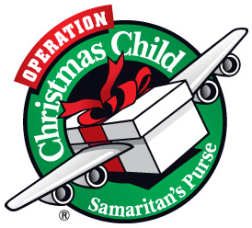

**OPERATION CHRISTMAS CHILD**

Share God’s love with girls and boys in the far corners of the world who have never heard of Jesus or received a present in His Name. Fill a shoe box with toys and gifts and Samaritan’s Purse will add Gospel literature so we will be able to bless a child’s life. “Whoever receives one of these little children in My name receives Me.” Mk 9:37a

Here’s how you can help (our goal is to fill 100 boxes):

1. Use an empty shoebox. Shoeboxes will be available for you to pick up today after service. You may wrap it (do the lid separately), but wrapping is not required. Determine age category (2-4, 5-9, 10-14) and gender of the child. ***Fill with gifts and bring to the church by Sunday, November 9*,**

OR

1. Bring in individual gift items and place in the box in the Narthex and the Sunday School will make up the shoe boxes,

OR

1. Make a monetary donation to help cover shipping costs and put it in the offering plate. Make checks out to CCC with a memo *for shoebox gifts.*

**Gift Ideas** (New items):

*Toys* – small cars, balls, dolls, stuffed animals, kazoos, harmonicas, yo-yos, jump ropes, small etch-a-sketch, lighted or noise-making toys (with batteries), slinky, etc.

*School Supplies* – pens, pencils with sharpener, crayons, markers, stamp and ink pad sets, writing pads, solar calculators, coloring and picture books

*Hygiene items* – toothbrush, toothpaste, mild bar soap (in plastic bag), comb, washcloth, etc.

*Other* – hard candy and lollipops (please double bag all candy), mints, gum, T-shirts, socks, ball caps, sunglasses, hair clips, jewelry, watches, flashlights (with batteries); a personal note/photo of yourself or family/address (put in an envelope).

[Do not include liquids, outdated food, war-related or breakable items.]

For more information, check out Samaritan Purse’s website: <http://www.samaritanspurse.org/operation-christmas-child/pack-a-shoe-box/> or call the church office. Tags to label your shoebox for age and gender will be available at church.