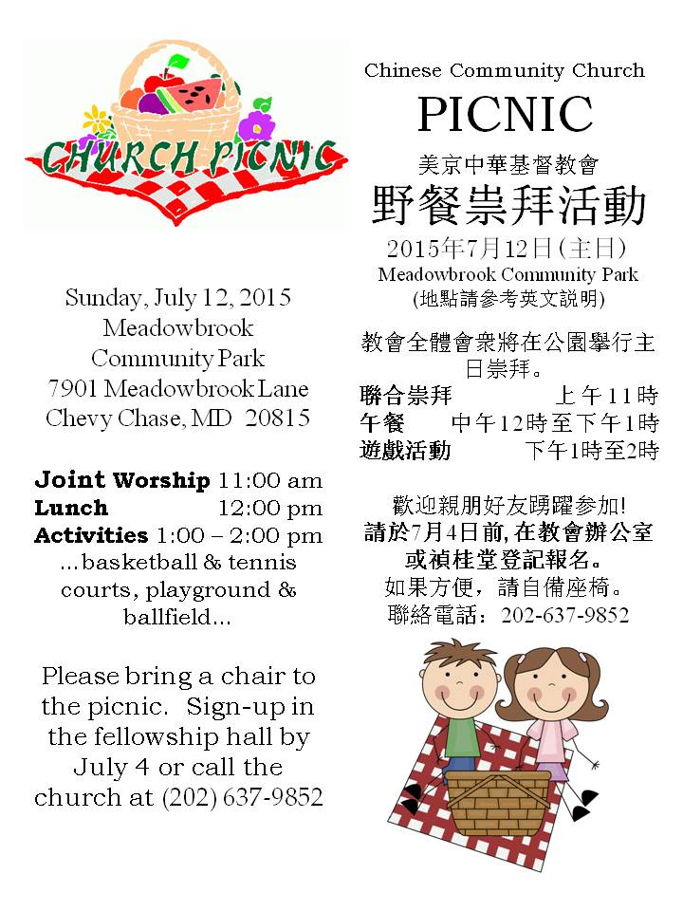

Meadowbrook Community Park,

7901 Meadowbrook Lane, Chevy Chase, MD 20815

*Start at: Capital Beltway*

1. Take exit 33 for MD-185/Connecticut Ave. toward Chevy Chase/Kensington - 0.1 mi
2. Keep right at the fork, follow signs for Connecticut Ave. 185 S/Chevy Chase and merge onto MD-185 S/Connecticut Ave. - 1.2 mi
3. Turn left at MD-410 E/E West Hwy. - 1.0 mi
4. Turn right at Meadowbrook Ln. - 223 ft

*Start at: 500 I St. NW, Washington, DC 20001*

1. Head west on I St. NW toward 6th St. NW - 200 ft
2. Take the 1st right onto 6th St. NW - 0.8 mi
3. Turn left at Rhode Island Ave. NW - 456 ft
4. Slight right at R St. NW - 164 ft
5. Take the 1st right onto 7th St. NW - 0.3 mi
6. Continue onto Georgia Ave. NW  Entering Maryland - 4.8 mi
7. Turn left at Eastern Ave. NW  Passing through District of Columbia Entering Maryland - 0.7 mi
8. At the traffic circle, take the 2nd exit onto 16th St. - 0.2 mi
9. Turn left at MD-410 W - 1.4 mi
10. Turn left at Meadowbrook Ln. - 259 ft
11. Slight left to stay on Meadowbrook Ln. - 0.2 mi