Summer Retreat, August 7-9, 2015
Messiah College
3 pm Friday – 1 pm Sunday

“How to Be a Christian
in a Non-Christian World”

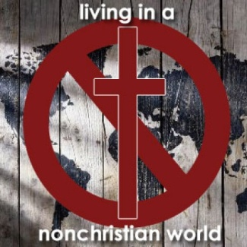
http://sbclondon.com

Retreat Speakers
David and Shannon Lamb
David Lamb is an Old Testament Professor at Biblical Theological Seminary in Philadelphia with impressive education, writing, and ministry experience. He earned degrees in economics and industrial engineering before receiving his M.Div. at Fuller Seminary and M. Phil. and D.Phil at University of Oxford. He had a long tenure on staff at InterVarsity and his book, God Behaving Badly: Is the God of the Old Testament Angry, Sexist and Racist has been well-received. He loves to pass on to others his love for God’s Word.
Shannon Lamb serves with InterVarsity Christian Fellowship both in the U.S. and abroad while also an adjunct staff member of Biblical Theological Seminary where she earned her M.Div. degree. She and David have two sons, Nathan and Neal.
Together the Lambs will conduct four sessions and lead Sunday Worship at the retreat.

Come to …
Be instructed in God’s Word
Be encouraged through fellowship
Be renewed by putting aside the cares of the world for a weekend
Besides the teaching, the schedule includes worship, sharing, plenty to eat, free time to enjoy the campus, recreation or nearby attractions. We are pleased that Jayne Mraz from Chinese Children’s Ministry will conduct sessions for the elementary-age children again.

.
Reservation deadline is July 27, 2015.

For online registration form, click here.

